30 Sept 2020 Rinoy Kuriyakose R3 56

**Experiment:8**

**Aim:**

Create a package ‘studpack’ which incorporates Student class and Sports interface. Create a Result class that extends Student class and implements a sports interface to display the total marks. The details of the classes and interfaces described below. Use appropriate access specifier as per the requirement. (*method, - variable)

Create a java program Hybrid.java that imports Result class from studpack and display the total for 5 students.

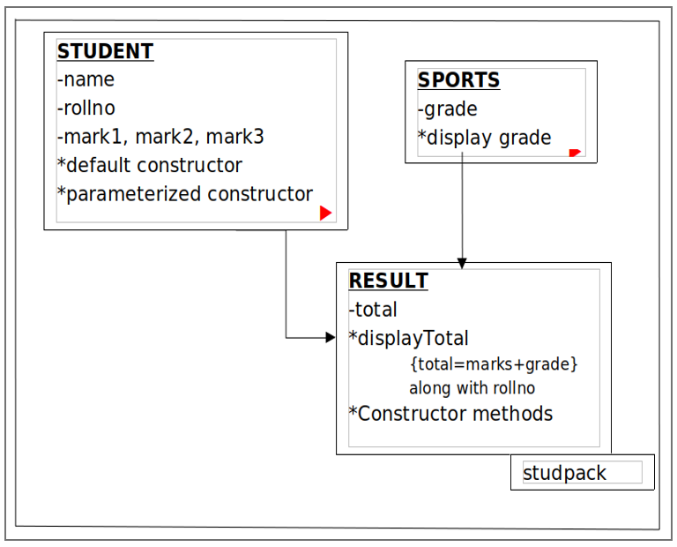

**Concepts Used:**

Package, Interface.

**Algorithm:**

Package studpack

1. Interface Sports with public static final field grade and public abstract method displayGrade

2. Class Student with fields name, rollNo, mark1, mark2, mark3 and required constructors

3. Class Result inherits Class Student and implements Interface Sports with field total, required constructors, definition for overriden method displayGrade, and displayTotal method

Class Hybrid

1. Import package studpack

2. Create Result object and call displayTotal method on it

**Program:**

package studpack

package studpack;  
  
class Student {  
 String name;  
 int rollno;  
 float mark1,mark2,mark3;  
 Student(){  
 mark1 = 0;  
 mark2 = 0;  
 mark3 = 0;  
 rollno = 0;  
 }  
 Student(String name,int rollno,float mark1,float mark2,float mark3){  
 this.name = name;  
 this.mark1 = mark1;  
 this.mark2 = mark2;  
 this.mark3 = mark3;  
 this.rollno = rollno;  
 }  
}  
  
interface Sports{  
 char grade='A';  
 char displayGrade();  
}  
  
public class Result extends Student implements Sports{  
  
 float total;  
 public char displayGrade(){  
 return grade;  
 }  
 public void displayTotal(){  
 total=mark1+mark2+mark3;  
 System.out.println(" "+rollno+" "+name+" "+total+" "+displayGrade());  
 }  
 public Result(String name,int rollno,float mark1,float mark2,float mark3){  
 super(name,rollno,mark1,mark2,mark3);  
 }  
}

Hybrid.java

import studpack.*;  
  
public class Hybrid{  
 public static void main(String[] args){  
 Result S1 =new Result(" Rinoy ",56,97,96,98);  
 Result S2 =new Result(" Royal ",58,78,60,50);  
 Result S3 =new Result(" Tejas ",60,90,89,91);  
 Result S4 =new Result(" Alex ",05,83,89,85);  
 Result S5 =new Result(" Joseph",45,90,81,89);  
 System.out.println("Roll No. Name Total Grade");  
 S1.displayTotal();  
 S2.displayTotal();  
 S3.displayTotal();  
 S4.displayTotal();  
 S5.displayTotal();  
 }  
}

**Output:**

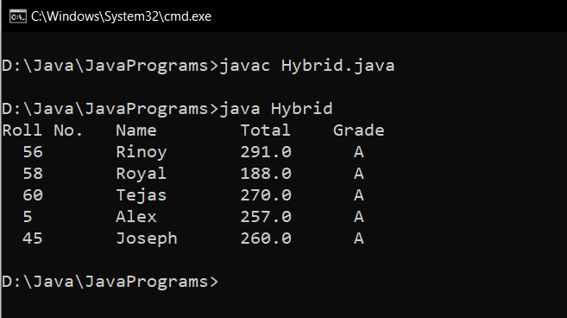

**Result:**

Package studpack is imported to another package and its classes are used there.